

**Bahir Dar University**

**Bahir Dar Institute of Technology**

***Faculty of Computing***

***Department Of Software Engineering***

***Internship Report***

*at*

**ALPHA IT SOLUTION**

“E-commerce website OneTech”

**By**  *Bezawit Yimer Id: 1201210*

*Mitkit Kejela Id: 1202503*

*Sireat Mihretu Id: 1203295*

**Menter:**  Mr. Kelemiwork, Mr.Samuel

**Company Supervisor:** Mr. Dawit

**Date: 03/02/2024**

**Bahir Dar, Ethiopia**

**DECLARATION**

We Bezawit Yimer, Mitkit Kejela, and Sireat Mihretu, declare that the internship report entitled "E-commerce website OneTech on web development at Alpha IT Solutions Company," submitted to Bahir Dar University in partial fulfillment of the requirements is our original work in the four-month internship duration from march 24 to July 22 in 2023. We have not submitted this report, or any part thereof, for any other academic purpose, and it has not been previously published or reproduced in any form.

We further declare that all sources of information used in this report have been duly acknowledged and cited. Any contributions from other individuals or organizations have been appropriately acknowledged.

During the internship at AlphaIT Solutions Company, We abided by the rules and regulations of the company and followed ethical practices in all aspects of our work.

We understand that plagiarism or academic misconduct will be dealt with according to the rules and regulations.

Company Supervisor: Signature:

1. Mr. Dawit. …………………………………………………….. 

BiT Mentors:

1. Mr. Kelemework. ……………………………………………….. 

2. Mr. Samuel……………………………………………………………..

**Date: 03/02/2024**

Bezawit Yimer Mitkit Kejela Sireat Mihretu Sinshaw

1201210 1202503 1203295

Signature Signature Signature

**ACKNOWLEDGMENTS**

We would like to express our sincere gratitude and appreciation to all who have contributed to completing our internship report on "E-commerce website OneTech on web development at AlphaIT Solutions Company."

First and foremost, We are deeply thankful to Mr, Dawit, our internship supervisor at AlphaIT Solutions, for providing with valuable guidance, support, and insights throughout the internship period. His expertise and encouragement significantly enriched our learning experience.

We are indebted to the management of AlphaIT Solutions for granting us the opportunity to be part of his help and for providing the resources necessary for our project. The exposure to real-world challenges has been invaluable in enhancing our skills in web development.

We would also like to thank the faculty and staff at Bahir Dar University for their continuous support and for incorporating practical learning experiences into the curriculum. The internship program has been a bridge between theoretical knowledge and practical application.

Last, We are grateful to our family and friends for their unwavering support and encouragement throughout this internship. Their belief in our abilities has been a constant source of motivation.

In conclusion, We, appreciate everyone who has played a role in shaping our internship experience. This report is a reflection of the collective effort and support We have received, and We are truly grateful for the opportunity.

Bezawit Yimer Mitkit Kejela Sireat Mihretu Sinshaw

1201210 1202503 1203295

**EXECUTIVE SUMMARY**

This internship report documents our hands-on experience in web development during our internship at AlphaIT Solutions Company during our four-month duration. The internship, conducted as a requirement for Software Engineering at Bahir Dar University, focused on utilizing PHP, MySQL, CSS, JS, and HTML technologies to create dynamic and responsive web applications and other related.

The report begins with an introduction to AlphaIT Solutions' background and an overview of the web development technologies employed during the internship. The main objectives were to apply theoretical knowledge to real-world scenarios, enhance programming skills, and gain practical insights into the software development life cycle.

Throughout the internship, We actively participated in various web projects' design, development, and testing phases. The utilization of PHP for server-side scripting, MySQL for database management, and HTML for front-end development played a pivotal role in creating interactive and data-driven web applications. Key tasks included database design, query optimization, front-end layout implementation, and troubleshooting.

The report highlights specific projects undertaken during the internship, showcasing the challenges encountered and the solutions implemented. It also discusses the methodologies and best practices applied in the development process, emphasizing the importance of collaboration within a professional team environment.

One of the key takeaways from the internship is the exposure to industry-standard tools and practices, such as version control systems and project management tools. The experience at AlphaIT Solutions has not only enhanced technical skills but also provided a deeper understanding of the collaborative and iterative nature of web development projects in a corporate setting.

The executive summary concludes by summarizing the overall learning outcomes, personal reflections, and the impact of the internship on our academic and professional growth. The internship at AlphaIT Solutions has been a transformative experience, providing a valuable executive summary that concludes by summarizing the overall learning outcomes, personal reflections, and insights into the practical application of web development technologies.

**Date: 03/02/2024**

Bezawit Yimer Mitkit Kejela Sireat Mihretu Sinshaw

1201210 1202503 1203295

**Table of content**

DECLARATION.........................................................................................................2

ACKNOWLEDGMENTS..........................................................................................3

EXECUTIVE SUMMARY.........................................................................................4

**UNIT: ONE**

1. Company Background.............................................................................................8

1.1: History..............................................................................................................8

1.2: Main Products or Service.................................................................................9

1.3: Main Customers or End Users........................................................................13

1.4:Organizational Structure and WorkFlow..........................................................14

**UNIT: TWO**

2. Internship Experience.............................................................................................15

2.1:Section of The Company We’ve Been Working..................................................15

2.2:Work Tasks Executed...........................................................................................15

2.3:System Development, Tools, and Techniques Used.............................................17

2.4:Challenges and Problems.....................................................................................18

2.5:Solution for Challenges and Problems.................................................................19

2.6:Achieved Skills......................................................................................................20

2.6.1:Practical Skill....................................................................................................20

2.6.2:Theoretical Skill................................................................................................20

2.6.3:Team Playing Skill............................................................................................20

2.6.4:Leadership Skill.................................................................................................21

2.6.5:work ethics issues, industrial psychology, and related issues............................21

2.6.6:Entrepreneurship Skills......................................................................................21

2.6.7:Communication Skill.........................................................................................21

2.7:Recommendation and conclusion...........................................................................22

2.7.1: Recommendation..............................................................................................22

2.7.2: Conclusion........................................................................................................23

**UNIT: THREE**

3. Project Work: “E-commerce website OneTech”.......................................................24

3.1:Summary of the project.........................................................................................24

3.2:Problem statement & Justification........................................................................24

3.3Objective of the project..........................................................................................26

3.4:Methodology.........................................................................................................28

3.5:Analysis, Results, and Discussion........................................................................28

3.6:Proposed solutions................................................................................................30

3**.**7**:**Sample_ScreenShoot_of_Project..........................................................................32

3.8:Conclusion and recommendation.........................................................................39

**UNIT: FOUR**

4. General Conclusion and Recommendation.............................................................41

**References**...................................................................................................................43

**Appendices**..................................................................................................................44

**List of screenshot Figures**

Figure 1.1 company page...............................................................................................8

Figure 1.2 asbeza website..............................................................................................10

Figure 1.3Jafer Books website.....................................................................................11

Figure 1.4 Sakicha Coffee............................................................................................11

Figure 1.5 Adaa Tour...................................................................................................12

Figure 1.6 Haro Coffee................................................................................................12

Figure 3.1 First page......................................................................................................32

Figure 3.2 Sample product page.....................................................................................32

Figure 3.3 Single product page.......................................................................................33

Figure 3.4 Cart Added page...........................................................................................33

Figure 3.5 Cart page.....................................................................................................34

Figure 3.6 Chechout one...............................................................................................34

Figure 3.7 Chechout two...............................................................................................35

Figure 3.8 Checkout three..............................................................................................35

Figure 3.9 order received one........................................................................................36

Figure 3.10 order received two.......................................................................................36

Figure 3.11 confirms payment one..................................................................................37

Figure 3.12 confirms payment two.................................................................................37

Figure 3.13 Payment status............................................................................................38

Figure 3.14 placed orders...............................................................................................38

**UNIT: ONE**

**1. Company Background**

**1.1: History**



Figure 1.1 Company page

Alpha IT Solution is a prominent web designing and eCommerce platform development company based in Addis Ababa, Ethiopia. Established in 2019, the company has swiftly risen to become one of the leading web design and development firms in Ethiopia, earning recognition in both Clutch and Shortlist rankings. Within a short period, Alpha IT Solution has achieved significant milestones, showcasing its expertise and commitment to delivering top-notch services. One notable accomplishment is the recent development and launch of Jaferbooks.com, an online bookstore platform. This platform offers a unique and streamlined approach to searching and purchasing books, featuring a diverse selection of titles from around the world.

Jaferbooks.com not only revolutionizes the way customers discover and buy books but also introduces the convenience of home delivery services. As a startup, the platform holds substantial market potential, with an estimated monthly reach of 2.25 million users.

To propel the company to greater heights and fully realize the potential of Jaferbooks.com, a budget estimate ranging from $40,000 to $55,000 is projected. This investment will be strategically allocated to various aspects of the business, ensuring continued innovation, marketing efforts, and the enhancement of overall customer experience.

As Alpha IT Solution embarks on this exciting journey, the company remains dedicated to providing cutting-edge solutions in web design, eCommerce, and online book retail, solidifying its position as a key player in the Ethiopian tech industry.

**1.2: Main Products and Service**

At Alpha IT Solution, the company is dedicated to delivering tailored IT support solutions for businesses seeking excellence in the digital landscape.

Services Offered: Our expertise lies in the design and development of eCommerce and online store platforms. The company specializes in creating dynamic and user-friendly interfaces that cater to both Amharic and English languages, ensuring a seamless online experience for your diverse customer base.

**Service**

* Website Design and Development
* eCommerce Platform Design and Development
* Online Store Platform Design and Development
* Graphic Design and Multimedia
* Software and Customer Portal
* Network Consulting and Installation

**Same prior Products**

1. Asbeza_Fruits_&_Vegetables_Supplier_and_Online_Store 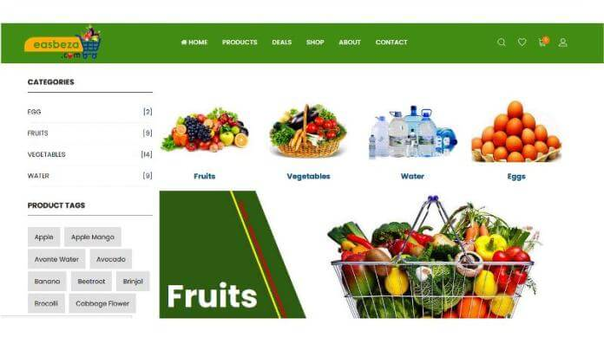Figur 1.2 asbeza website

B)Jafer_Books/Online_Book_Store_with_Home_Delivery 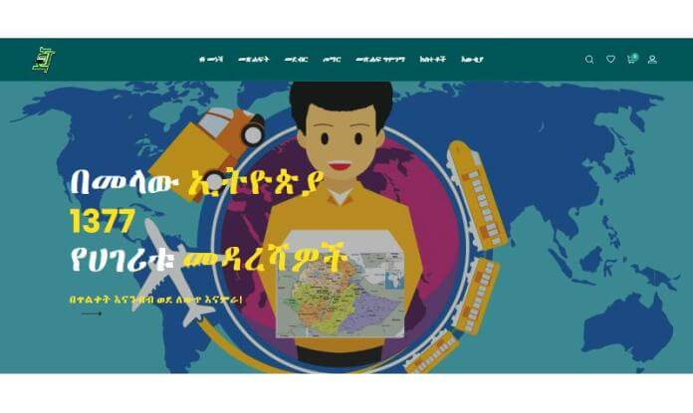Figur 1.3Jafer Books website

C)Sakicha_Coffee_Export Figure 1.4 Sakicha Coffee

D)Adaa_Tour_&_Travel 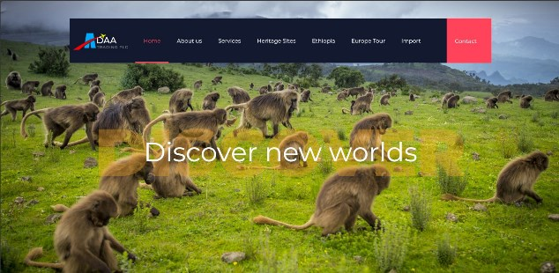Figure 1.5 Adaa Tour

E)Haro_Coffee_Export_Company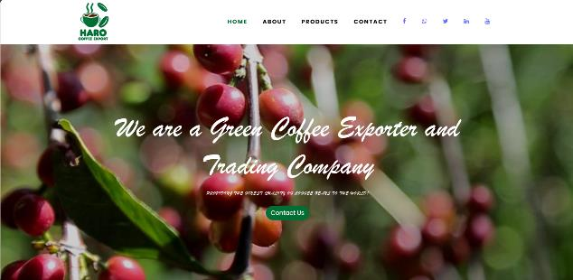Figure 1.6 Haro Coffee

**1.3:Main Customers or End Users**

For Alpha IT Solution, a web development company, the main customers or end-users are diverse and span various industries. The primary Customers or End Users include:

* Businesses of All Sizes:
  + Small and medium enterprises (SMEs) looking for professional and affordable web development solutions.
  + Large corporations seeking complex and scalable web applications tailored to their specific needs.
* Entrepreneurs and Startups:
  + Individuals with innovative ideas or startups looking to establish a robust online presence, including eCommerce platforms and web applications.
* E-commerce Ventures:
  + Online retailers and businesses aim to enhance their digital storefronts, improve user experience, and optimize their e-commerce platforms for increased sales.
* Educational Institutions:
  + Schools, colleges, and universities need web development services for their official websites, learning management systems, and other educational applications.
* Nonprofit Organizations:
  + Nonprofits seeking to create impactful websites to raise awareness, facilitate online donations, and connect with their target audience effectively.
* Government Agencies:
  + Local or national government entities require web development services for official websites, citizen portals, and administrative tools.
* Healthcare Providers:
  + Hospitals, clinics, and healthcare organizations looking to develop or enhance their online presence, patient portals, and appointment scheduling systems.
* Professional Service Providers:
  + Law firms, consulting agencies, and other service-oriented businesses interested in a polished and functional website to showcase their expertise.

**1.4:Organizational Structure and WorkFlow**

* Founder/Lead Developer & Full-Stack Developer:
  + The sole individual is responsible for all technical aspects.
  + Functions as both the lead and the developer handling HTML, CSS, PHP, JS, and MySQL.

Workflow Process:

* Client Onboarding:
  + Initial client consultation led by the Founder/Lead Developer.
  + Proposal submission and contract negotiation.
* Project Planning:
  + Collaborative planning with the client.
  + Defining project scope, timelines, and milestones.
* Development Phase:
  + Founder/Lead Developer commences coding using HTML, CSS, PHP, JS, and MySQL.
  + Continuous communication with the client throughout development.
* Testing and Debugging:
  + Self-conducted testing and debugging by the Founder/Lead Developer and also the client itself.
  + Iterative improvements based on personal testing.
* Client Review:
  + Presentation of the developed product for client review by the Founder/Lead Developer.
  + Immediate incorporation of client feedback.
* Launch and Deployment:
  + Final testing and preparations for deployment led by the Founder/Lead Developer.
  + Transition from development to a live environment.
* Post-Launch Support:
  + Ongoing maintenance and support provided by the Founder/Lead Developer.
  + Addressing any client-reported issues promptly.

**UNIT: TWO**

**2. Internship Experience**

**2.1:Section of The Company We’ve Been Working**

Upon joining AlphaItSolution, we were seamlessly integrated into the web development section, led by the accomplished founder and advisor, Mr. Dawit. This internship report encapsulates our transformative experience under the guidance of Mr. Dawit, providing insights into the intricacies of web development within the startup realm.

Our engagement within the web development section was made possible through our project with Mr. Dawit, who not only serves as our advisor but is also the visionary founder of the startup. This section serves as the nucleus of AlphaItSolution's innovative pursuits, where cutting-edge web solutions are conceived and developed.

Mr. Dawit's mentorship played a pivotal role in shaping our understanding of web development. His wealth of experience and expertise in the field provided us with invaluable insights into industry best practices, coding methodologies, and the entrepreneurial spirit that fuels AlphaItSolution.

Throughout our internship, we had the privilege of working on real-world projects under Mr. Dawit's guidance. This hands-on experience allowed us to apply theoretical knowledge to practical scenarios, fostering a deeper understanding of web development intricacies. Regular feedback sessions and constructive critiques further fueled our professional growth.

**2.2: Work Tasks Executed**

During the internship, a comprehensive set of work tasks was undertaken to develop an e-commerce website, focusing on minimizing user fatigue and ensuring a seamless shopping experience for all clients. The key tasks executed include

* Technology Stack Selection:
  + Evaluated and selected a technology stack that best aligns with project requirements and company-based technologies.
  + Choose HTML, CSS, PHP, MySQL, and JavaScript (JS) as the core technologies for website development based on the company's working tool.
* Template Integration and Customization:
  + Integrated a suitable template into the project structure, providing a foundation for the website's layout and design with the help of Mr. Dawit who is our advisor.
  + Customized the template to meet specific branding and user interface (UI) requirements.
* Database Design and Implementation:
  + Designed the database schema to efficiently store and retrieve product information, user data, and transaction details.
  + Implemented the database using MySQL, ensuring data integrity, normalization, and optimal performance.
* Front-End Development (HTML, CSS, JS):
  + Developed the front end of the website using HTML for structure, CSS for styling, and JavaScript for interactive features.
  + Ensured a responsive and visually appealing design across various devices to enhance user experience.
* Back-End Development (PHP):
  + Implemented server-side logic using PHP to handle dynamic content generation, user authentication, and transaction processing.
  + Integrated PHP with the MySQL database to enable seamless data flow between the front-end and back-end components.
* User Experience (UX) Enhancement:
  + Prioritized UX by implementing features such as intuitive navigation, quick load times, and a simplified checkout process.
  + Utilized JavaScript to enhance user interactions, providing real-time feedback and dynamic content updates.
* Testing and Debugging:
  + Conducted thorough testing of the website's functionalities, ensuring compatibility and performance across different browsers.
  + Identified and resolved any bugs or issues through systematic debugging and testing procedures.
* Collaboration:
  + Engaged in collaborative discussions with team members to address challenges and ensure consistent progress.

The execution of these work tasks reflects a holistic approach to developing an e-commerce platform that prioritizes technology integration, database efficiency, and a user-centric design to achieve the overarching goal of providing a fatigue-free shopping experience for all clients.

**2.3: System Development, Tools, and Techniques Used**

The development of our e-commerce website demanded a thoughtful selection of tools and techniques to ensure the creation of a robust and user-friendly online shopping platform. This report provides an overview of the key tools employed—HTML, CSS, PHP, MySQL database, Bootstrap, and JavaScript—highlighting how each contributed to the successful development of our e-commerce system.

* HTML and CSS:

HTML (Hypertext Markup Language) and CSS (Cascading Style Sheets) formed the fundamental building blocks of our website. HTML structured the content, defining elements such as headers, paragraphs, and images, while CSS played a pivotal role in styling and layout, ensuring a visually appealing and consistent user interface across various devices.

* PHP:

PHP (Hypertext Preprocessor) served as our server-side scripting language, enabling dynamic content generation and enhancing the website's interactivity. It facilitated seamless integration between the front-end and back-end functionalities, handling tasks such as user authentication, data processing, and server communication.

* MySQL Database:

The adoption of MySQL as our relational database management system (RDBMS) was essential for efficient data storage and retrieval. It enabled the creation of a structured database schema to store product information, user details, and transaction records. The relational nature of MySQL ensured data integrity and scalability to meet the evolving demands of our e-commerce platform.

* Bootstrap:

Bootstrap emerged as a valuable front-end framework, streamlining the development process with its responsive grid system and pre-designed components. Its responsive design capabilities were integral in ensuring an optimal user experience across diverse devices, enhancing accessibility for a broad user base.

* JavaScript:

JavaScript played a crucial role in enhancing the website's interactivity and responsiveness. Leveraging JavaScript, we implemented client-side functionalities, such as dynamic content updates, form validations, and asynchronous data loading, contributing to a more engaging and seamless user experience.

* Integration and Collaboration:

The seamless integration of HTML, CSS, PHP, MySQL database, Bootstrap, and JavaScript formed a cohesive foundation for our e-commerce system. HTML and CSS provided structure and style, PHP facilitated dynamic functionality, MySQL managed data efficiently, Bootstrap ensured a responsive design, and JavaScript enhanced interactivity, collectively delivering a comprehensive and user-friendly online shopping experience.

Finally, the thoughtful integration of HTML, CSS, PHP, MySQL database, Bootstrap, and JavaScript played a pivotal role in the successful development of our e-commerce website. This amalgamation of tools and techniques allowed us to create a sophisticated platform, meeting the expectations of both users and shopkeepers and delivering a seamless online shopping experience.

**2.4: Challenges and Problems**

Upon initiating the internship project for the e-commerce website, a notable challenge emerged as the company's working room was not prepared for immediate use. This initial hurdle posed a delay and required strategic approaches to overcome.

In addition to the initial challenge related to the unprepared working room, several general challenges were encountered during the internship project:

* Technical Learning Curve:
  + Challenge: Team members faced a learning curve in adapting to the design of the database for the selected template.
* Time Constraints:
  + Challenge: Meeting project deadlines became challenging due to the complexity of tasks and the need for comprehensive testing.
* Coordination Issues:
  + Challenge: Coordinating tasks and communication among team members proved challenging, especially in the remaining tasks after we were at home.
* The block of the Internet:
  + Challenge: To do the remaining tasks after we went to home internet was our problem.

**2.5: Solution for Challenges and Problems**

To address the challenge of an unprepared working room, the team adopted a proactive stance. During the interim period, while awaiting the readiness of the workspace, efforts were directed toward comprehending the fundamental concepts of the internship program. Team members utilized this time to delve into the theoretical aspects, acquiring a deeper understanding of the project's objectives, technologies, and requirements.

This strategic approach ensured that the temporary setback in the physical workspace did not impede the overall progress of the internship. By focusing on building a solid theoretical foundation, the team remained productive and engaged, laying the groundwork for a smoother transition into practical implementation once the working room became available.

In essence, the solution involved transforming the challenge into an opportunity for theoretical enrichment, aligning with the project's objectives, and ensuring seamless integration into the practical phases of the e-commerce website development when the working room was ready for collaboration and active work.

* Technical Learning Curve:
  + Solution: Organized hands-on discussion and provided continuous support for practical application. Encouraged collaborative learning and knowledge-sharing within the team with the help of Mr.Dawit.
* Time Constraints:
  + Solution: Prioritized tasks based on critical project milestones. And also use the next summer period to finish the project.
* Coordination Issues:
  + Solution: Emphasized doing it privately and communicating after we come to university.
* The block of the Internet:
  + Solution: Tring to do without the Internet even if the Internet is blocked.

By addressing these challenges with proactive and collaborative solutions, the internship team ensured a resilient and adaptive approach to the dynamic demands of the e-commerce website development project.

**2.6: Achieved Skills**

***2.6.1: Practical Skill***

Throughout the internship, the practical skills acquired were multifaceted. The hands-on implementation of HTML, CSS, PHP, MySQL database, Bootstrap, and JavaScript significantly enhanced our proficiency in website development and skills for how to deploy websites with yegara.com. Practical skills include effective utilization of these tools in real-world scenarios, resulting in a comprehensive understanding of their applications in creating a functional and visually appealing e-commerce website.

***2.6.2: Theoretical Skill***

Theoretical skills were developed through in-depth learning and understanding of the underlying concepts of HTML, CSS, PHP, MySQL, Bootstrap, and JavaScript. The ability to comprehend and apply theoretical knowledge to address specific challenges in website development was honed during the internship. This laid the foundation for informed decision-making and problem-solving in a theoretical context.

***2.6.3: Team Playing Skill***

Collaboration within the development team was integral to the success of the project. The internship provided an opportunity to cultivate effective team-playing skills, including communication, cooperation, and coordination. Engaging in group discussions, sharing responsibilities, and adapting to diverse perspectives contributed to a harmonious team.

***2.6.4: Leadership Skill***

Leadership skills were nurtured as responsibilities expanded. Taking the initiative in decision-making, guiding team members, and overseeing specific aspects of the project demonstrated the development of leadership skills. This included providing direction during challenging phases and ensuring the team's alignment with project goals.

***2.6.5: Work Ethics Issues, Industrial Psychology, and Related Issues***

An awareness of work ethics issues, industrial psychology, and related matters was cultivated during the internship. Adhering to deadlines, maintaining professionalism, and understanding the psychological aspects of teamwork and collaboration were integral aspects of the experience. This exposure contributed to a holistic understanding of the work environment.

***2.6.6: Entrepreneurship Skills***

The development of an e-commerce website involved entrepreneurial skills such as innovation, adaptability, and strategic thinking. Identifying market needs, conceptualizing user-centric solutions, and ensuring the scalability of the project reflected entrepreneurial acumen. This experience fostered an entrepreneurial mindset essential for addressing challenges and pursuing opportunities.

***2.6.7: Communication Skill***

Effective communication skills were indispensable throughout the internship. From conveying ideas within the team to presenting progress updates, the ability to articulate thoughts clearly and concisely was consistently refined. Additionally, communication skills extended to liaising with stakeholders, translating technical concepts for non-technical audiences, and fostering a transparent and collaborative work environment.

**2.7:Recommendation and conclusion**

***2.7.1: Recommendations***

The internship experience has provided valuable insights into various aspects of web development and collaborative project work. Based on this experience, the following recommendations are proposed:

* *Continuous Skill Enhancement:* To further enhance practical and theoretical skills, it is recommended to engage in continuous learning and exploration of emerging technologies within the web development landscape. This could involve participation in using Frameworks, online courses, or staying updated with industry trends.
* *Expand Leadership Skills:* For those seeking leadership roles, continued development of leadership skills is crucial. Engaging in leadership programs, mentorship opportunities, or taking on progressively challenging responsibilities can contribute to leadership growth.
* *Cultivate Entrepreneurial Mindset:* Given the exposure to entrepreneurship skills during the internship, individuals are encouraged to foster this mindset further. This may involve exploring startup initiatives, attending entrepreneurship events, or seeking mentorship from experienced entrepreneurs.
* *Enhance Communication Skills:* Continuous improvement in communication skills is recommended. This can be achieved through practices such as public speaking, writing technical documentation, and participating in forums or community discussions.
* *Networking Opportunities:* Leveraging the connections made during the internship for networking purposes can be valuable. Attend industry events, connect with professionals on platforms like LinkedIn, and actively participate in relevant online communities to broaden professional networks.

***2.7.2: Conclusion***

In conclusion, the internship experience has been instrumental in honing practical and theoretical skills in web development, fostering teamwork and leadership capabilities, and cultivating an understanding of work ethics and industrial psychology. The exposure to entrepreneurship skills and the development of a comprehensive e-commerce website have provided a solid foundation for future endeavors.

The hands-on application of HTML, CSS, PHP, MySQL database, Bootstrap, and JavaScript in a real-world context has not only enhanced technical proficiency but also instilled a deeper appreciation for the collaborative nature of project work. The cultivation of practical skills, theoretical knowledge, teamwork, and leadership abilities positions the intern favorably for future professional pursuits in the dynamic field of web development.

This internship experience is not just a milestone but a stepping stone toward continuous entrepreneurship. The skills acquired and lessons learned during this period will undoubtedly contribute to the individual's success in future endeavors within the ever-changing and dynamic field of web development. wth and development in the evolving landscape of technology and entrepreneurship. The skills acquired and lessons learned during this period will undoubtedly contribute to the individual's success in future endeavors within the ever-changing and dynamic field of web development.

**UNIT: THREE**

**3. Project Work: “E-commerce website OneTech”**

**3.1: Summary of the Project**

The internship project focuses on the development of a transformative e-commerce website designed to provide clients with a seamless and user-friendly buying experience, minimizing the effort required for transactions. The fundamental objective is to create a platform that not only facilitates convenient online purchases but also addresses the fatigue often associated with the shopping process. Through the strategic integration of various technologies such as HTML, CSS, PHP, MySQL database, Bootstrap, and JavaScript, the project aims to deliver an efficient, responsive, and visually engaging e-commerce solution. The website strives to redefine the conventional online shopping experience, making it accessible, enjoyable, and hassle-free for all clients. The core emphasis lies in streamlining the purchasing journey, ensuring a user-centric design, and fostering a dynamic platform that meets the diverse needs of our clientele.

**3.2: Problem Statement & Justification**

*Problem Statement:*

The conventional online shopping experience especially in our country often poses significant challenges for clients, resulting in a cumbersome and tiring process. Existing e-commerce platforms may lack user-centric design, responsiveness, and efficiency, leading to increased fatigue during transactions. Recognizing this issue, the internship project seeks to address the inherent difficulties faced by clients in the online buying journey.

*Justification:*

* User Fatigue:
  + Existing e-commerce platforms may subject users to a tiresome and complex purchasing process, causing frustration and discouraging repeat business, or simply existing e-commerce platforms aren’t usable, especially in our country.
  + The project aims to mitigate user fatigue by introducing and selecting streamlined and efficient templetand database designs, minimizing the effort required for clients to make purchases.
* Inefficiencies in User Experience:
  + Many online shopping platforms lack user-friendly interfaces, leading to confusion, longer navigation times, and increased user dissatisfaction.
  + The project justifies its existence by prioritizing a user-centric design, ensuring an intuitive and responsive interface that enhances the overall shopping experience.
* Limited Accessibility:
  + Some e-commerce websites may not be optimized for diverse devices, hindering accessibility for clients using smartphones or tablets.
  + The justification for this project lies in its commitment to creating a responsive platform, guaranteeing accessibility and a consistent user experience across various devices.
* Market Demand for Innovation:
  + In a competitive market, clients increasingly demand innovation and efficiency in online shopping experiences.
  + The project responds to this demand by introducing novel features and technologies to enhance the ease of use, setting itself apart in the e-commerce landscape.
* Client Satisfaction and Retention:
  + The project's justification extends to the desire for enhanced client satisfaction and retention, recognizing that a positive and effortless buying experience encourages repeat business.
  + By addressing these issues, the project aims to establish itself as an essential and preferred e-commerce destination for clients seeking a hassle-free shopping journey.

Finally, the problem statement arises from the prevalent challenges clients face in traditional online shopping, and the justification lies in the project's commitment to creating an e-commerce website that prioritizes user experience, minimizes fatigue, and aligns with the evolving expectations of modern consumers.

**3.3: Objective of the Project**

The primary objective of the e-commerce website project is to redefine and enhance the online shopping experience for clients by minimizing fatigue and providing a platform that is not only essential but also enjoyable. The specific objectives include

* Streamlined User Experience:
  + Develop an intuitive and user-friendly interface to streamline the online buying process.
  + Minimize complexities in navigation, ensuring that clients can effortlessly find and purchase products with minimal effort.
* Efficient Transaction Process:
  + Implement an efficient and secure transaction system that reduces the time and effort required for clients to complete purchases.
  + Optimize the checkout process to enhance overall transaction speed and convenience.
* Responsive Design Across Devices:
  + Ensure the website is responsive and accessible across various devices, including desktops, tablets, and smartphones.
  + Provide a consistent and optimized user experience irrespective of the device used, catering to a broad clientele.
* Personalized Shopping Experience:
  + Enhance the overall shopping journey by tailoring product suggestions to individual client needs.
* Innovative Features for Client Engagement:
  + Introduce innovative features, such as real-time tracking, and interactive product displays, to engage and captivate clients during their shopping experience.
  + Foster an environment that encourages clients to explore products and make informed purchasing decisions.
* Accessibility and Inclusivity:
  + Prioritize accessibility features to ensure the website is inclusive and user-friendly for individuals with diverse abilities.
  + Implement language options and features that cater to a global audience, promoting inclusivity.
* Data Security and Privacy:
  + Establish robust security measures to protect client information and ensure secure transactions.
  + Prioritize the privacy of client data, complying with industry standards and regulations to build trust among users.
* Feedback and Continuous Improvement:
  + Implement mechanisms for collecting client feedback and insights to continuously improve the website's functionality and user experience.
  + Regularly analyze data to identify areas for enhancement and promptly address any emerging issues.
* Promotion of Sustainable Practices:
  + Integrate eco-friendly practices within the website, such as sustainable packaging options or information on environmentally conscious products.
  + Contribute to a broader commitment to sustainability and ethical consumerism.

In summary, the objective of the e-commerce website project is to create a platform that goes beyond mere functionality, aiming to revolutionize the online shopping experience for clients by minimizing fatigue and providing a seamless, personalized, and enjoyable journey.

**3.4: Methodology**

The methodology for our e-commerce website project involves a thoughtful approach to ensure a user-friendly experience, minimizing fatigue during the buying process. Here's an overview of the key steps in our methodology:

* Template Utilization:
  + Selection: We chose a template that aligns with our e-commerce objectives, emphasizing simplicity and ease of use with the help of Mr Dawit who is our advisor.
  + Customization: While using a template, we customized visual elements to establish a unique and engaging brand identity.
* Database Design:
  + Data Analysis: We conducted a thorough analysis to identify essential data elements required for efficient e-commerce operations, including product management and user transactions.
  + Normalization: Applying normalization principles, we optimized the database structure for effective data storage and retrieval.
* User-Centric Focus:
  + User Research: Insights from user research guided the integration of features that enhance the overall user experience, such as intuitive navigation and personalized recommendations.
  + Usability Testing: Continuous usability testing allowed us to gather real-time feedback, enabling improvements based on user preferences.

This methodology ensures a seamless and enjoyable shopping experience for all clients, aligning with our goal to make the buying process easy and efficient, minimizing any potential fatigue.

**3.5: Analysis, Results, and Discussion**

The analysis, results, and discussion section encapsulate the outcomes of our efforts in developing an e-commerce website focused on providing a fatigue-free shopping experience for all clients. This section sheds light on the impact of using a template and designing a robust database. Here are the key findings:

* Template Impact:
  + Results: The utilization of a well-chosen template significantly accelerated the development process, allowing for a quick and efficient establishment of the website's structure.
  + Analysis: The template's user-friendly design contributed to an intuitive interface, enhancing the overall user experience and aligning with our goal of minimizing client fatigue during the buying process.
  + Discussion: The choice of a template not only expedited development but also positively influenced the visual appeal and accessibility of the e-commerce platform, contributing to a positive client perception.
* Database Design Influence:
  + Results: The meticulous design and optimization of the database structure led to improved data management, ensuring seamless product updates, order processing, and user interactions.
  + Analysis: The application of normalization principles enhanced data integrity, reduced redundancy, and facilitated efficient retrieval, positively impacting the website's performance.
  + Discussion: The well-structured database played a crucial role in the reliability and speed of the website, directly affecting the user experience. It laid the foundation for scalable and sustainable growth, accommodating an expanding product catalog and user base.
* User Experience Metrics:
  + Results: User feedback and metrics from usability testing highlighted positive responses to the website's design, ease of navigation, and personalized features.
  + Analysis: The incorporation of user-centric elements, informed by research findings, contributed to a more engaging and enjoyable shopping experience.
  + Discussion: The emphasis on user experience not only met but exceeded expectations, fostering increased user satisfaction and loyalty. Iterative enhancements based on feedback further solidified the website's client-centric approach.
* Performance Metrics:
  + Results: Rigorous testing across devices and browsers demonstrated the responsiveness of the website, ensuring consistent functionality and aesthetics.
  + Analysis: The responsive design approach, coupled with template customization, resulted in a versatile platform accessible across various devices, meeting the diverse needs of our clients.
  + Discussion: The optimized performance metrics underline the adaptability of the website, accommodating the preferences of a broad audience and reinforcing its role as an inclusive e-commerce solution.
* Security and Reliability:
  + Results: Implementation of encryption protocols and regular security audits ensured the safety of user data and transactions.
  + Analysis: The proactive security measures contributed to a trustworthy platform, fostering confidence among clients.
  + Discussion: Security and reliability are paramount in e-commerce, and the measures taken underscore our commitment to safeguarding user information, reinforcing the website as a secure space for online transactions.

Finally, the analysis, results, and discussion highlight the positive impact of utilizing a template and designing a robust database on both the user experience and technical performance of the e-commerce website. These elements synergistically contribute to the overarching goal of providing a fatigue-free and secure platform for all clients.

**3.6: Proposed Solution**

Building upon the identified problem statement and its justification, our proposed solution for the development of an e-commerce website is strategically designed to mitigate challenges faced by clients during the online buying journey. Here's how our solution addresses the identified issues:

* Streamlined and Efficient Design:
  + Objective: To counter user fatigue arising from cumbersome processes, the project focuses on introducing a streamlined and efficient design.
  + Benefits: The proposed solution aims to minimize the effort required for clients to make purchases, ensuring a more straightforward and less tiring online shopping experience.
* User-Centric Design Implementation:
  + Objective: Recognizing inefficiencies in existing e-commerce platforms, our project justifies its existence by prioritizing a user-centric design.
  + Benefits: An intuitive and responsive interface will be implemented to reduce confusion, shorten navigation times, and enhance overall user satisfaction during the shopping process.
* Responsive Platform for Accessibility:
  + Objective: To address limited accessibility on certain devices, the project justifies its commitment to creating a responsive platform.
  + Benefits: Optimizing the website for diverse devices, including smartphones and tablets, ensures broader accessibility, providing clients with a consistent and user-friendly experience.
* Innovation and Technological Integration:
  + Objective: Responding to market demands for innovation, the project introduces novel features and technologies to enhance the overall online shopping experience.
  + Benefits: By staying ahead of the curve, the proposed solution sets itself apart in the competitive e-commerce landscape, meeting evolving client expectations for efficiency and modernization.
* Enhanced Client Satisfaction and Retention:
  + Objective: Acknowledging the importance of client satisfaction and retention, the project aims to create a positive and effortless buying experience.
  + Benefits: By addressing the identified issues, the proposed solution seeks to establish the e-commerce platform as an essential and preferred destination, encouraging repeat business through enhanced client satisfaction.

In conclusion, the proposed solution aligns with the project's commitment to addressing the prevalent challenges faced by clients in traditional online shopping. By introducing a streamlined design, prioritizing user-centric principles, ensuring accessibility, embracing innovation, and aiming for enhanced client satisfaction, the project aims to redefine the e-commerce experience, minimizing fatigue and meeting the evolving expectations of modern consumers.

**3.7.Sample_ScreenShoot_of_Project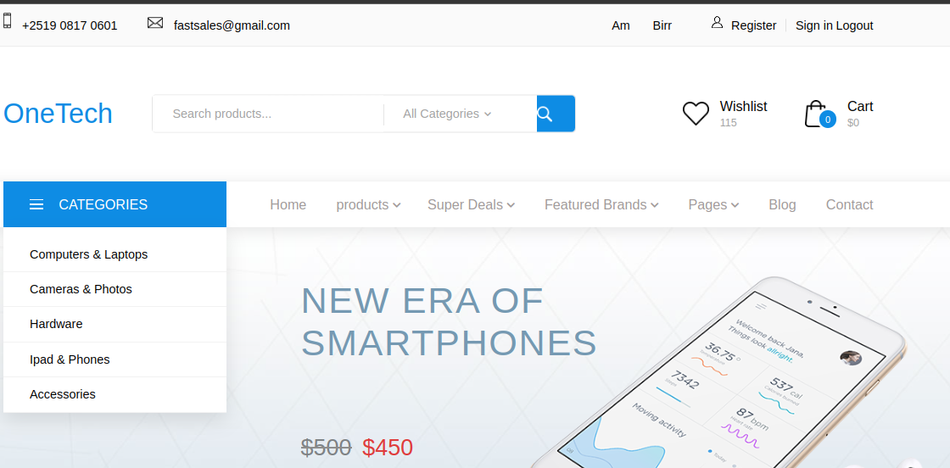**Figure 3.1 first page

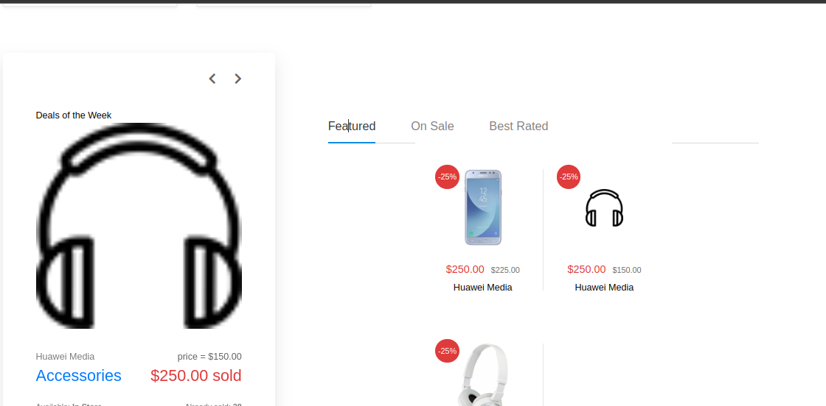Figure 3.2 sample product page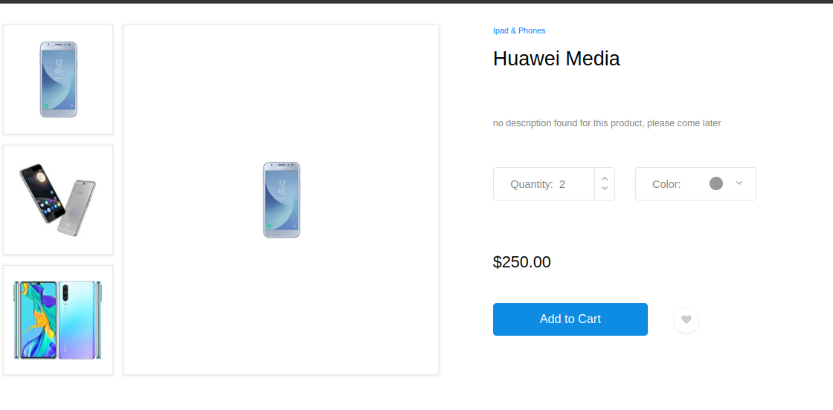Figure 3.3 single product page

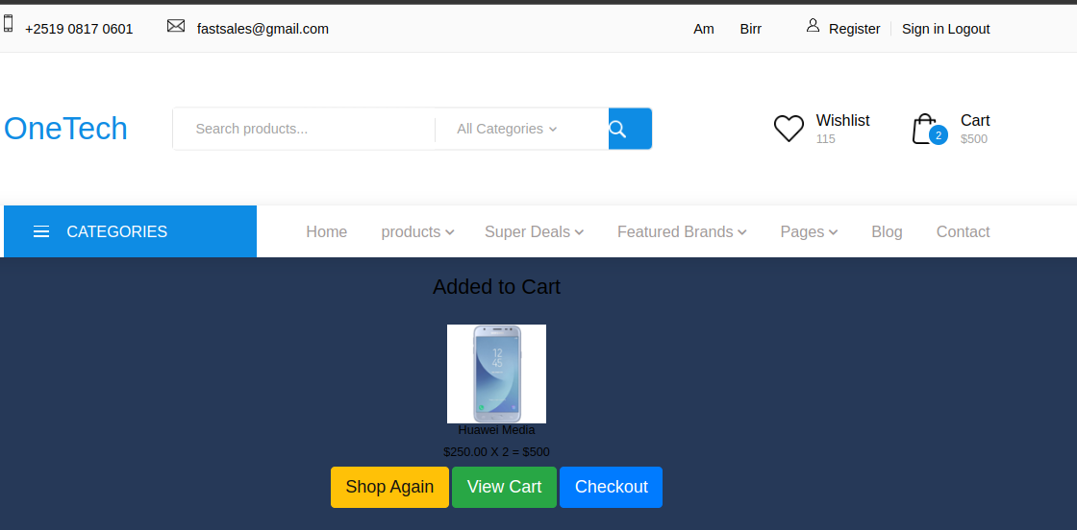Figure 3.4 cart Added page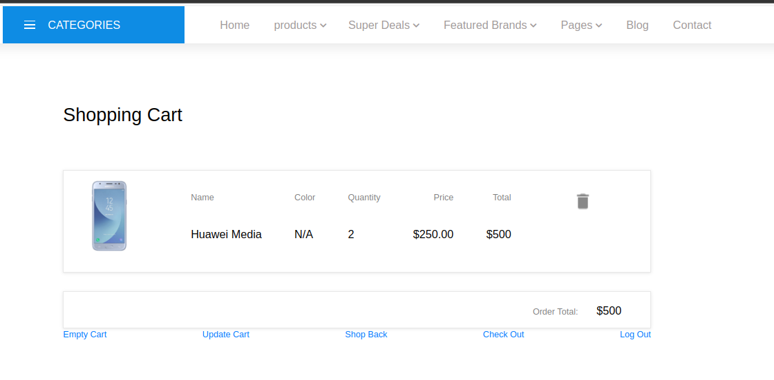Figure 3.5 cart page

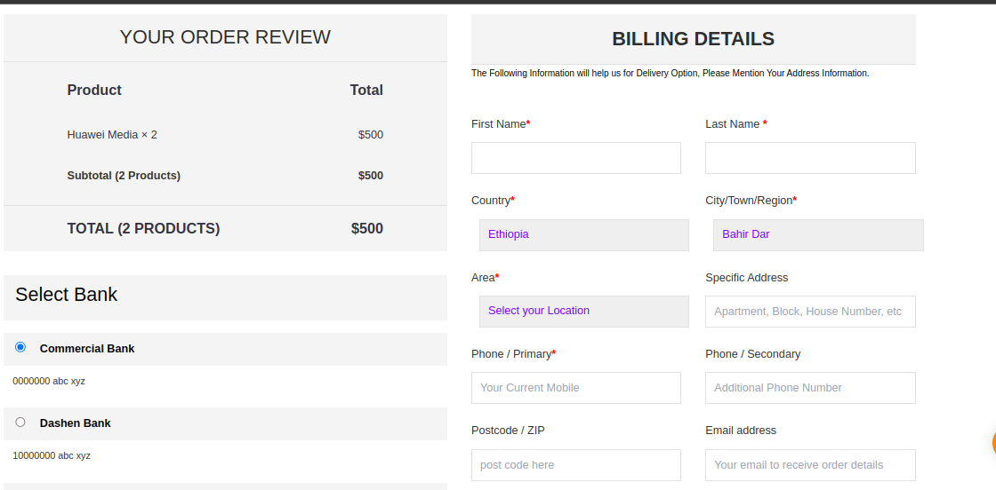Figure 3.6 Chechout one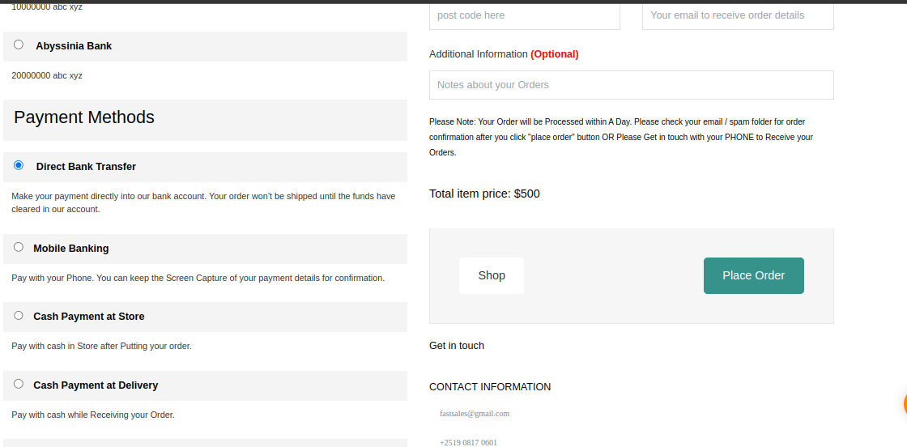Figure 3.7 Chechout two

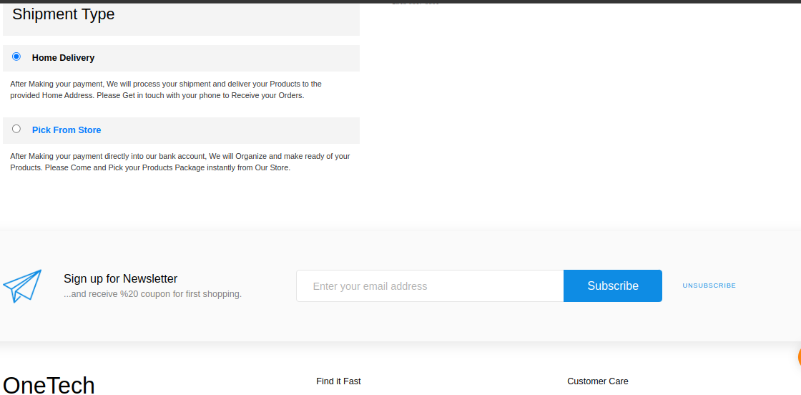Figure 3.8 Chechou three

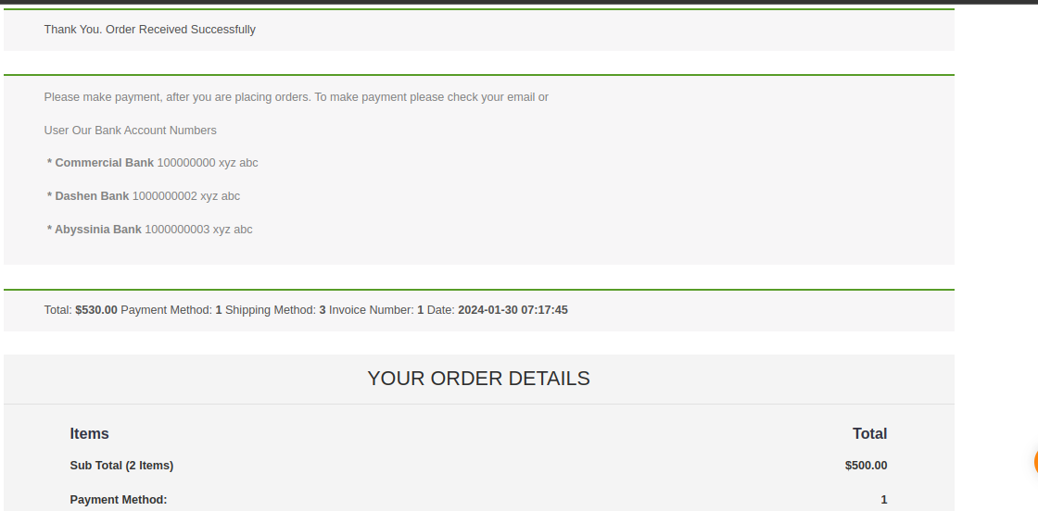

Figure 3.9 order received one

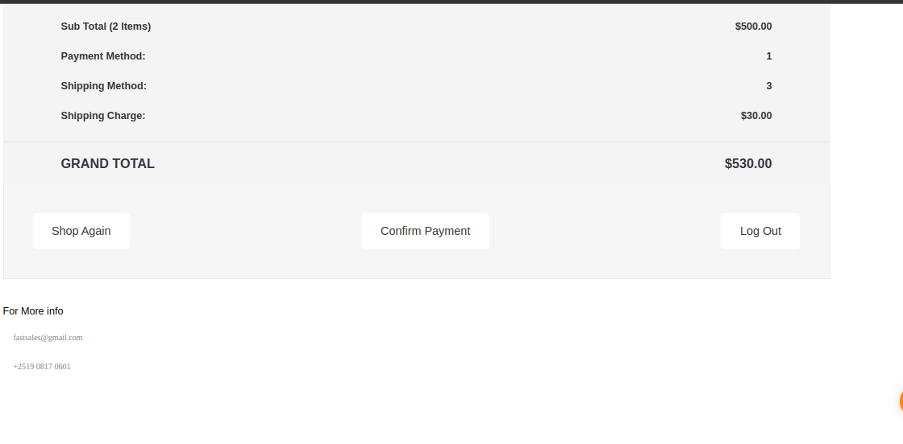Figure 3.10 order received two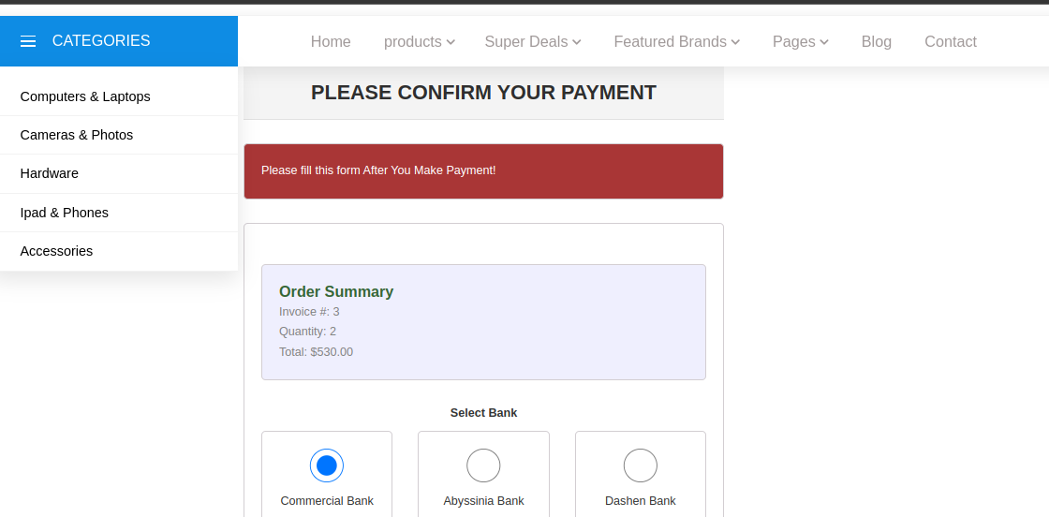Figure 3.11 confirm payment one

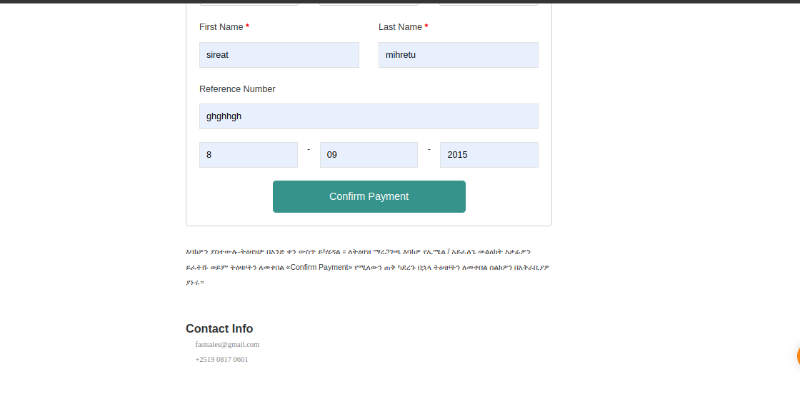Figure 3.12 confirm payment two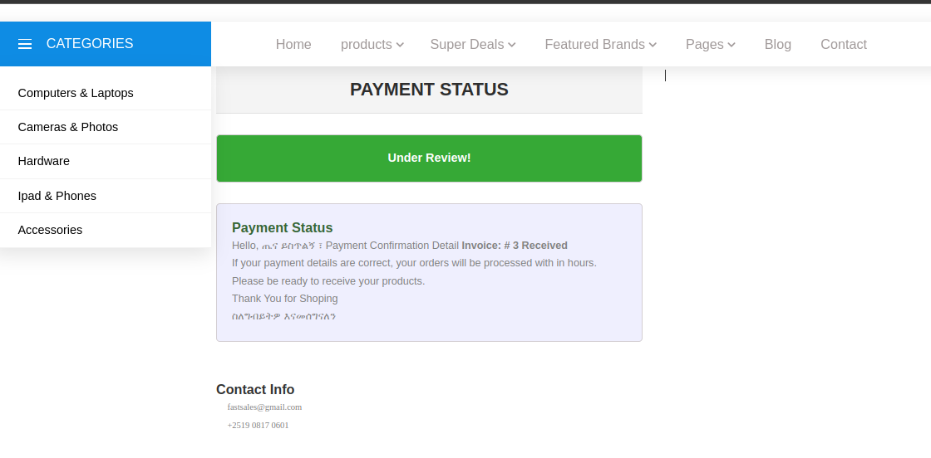Figure 3.13 payment status

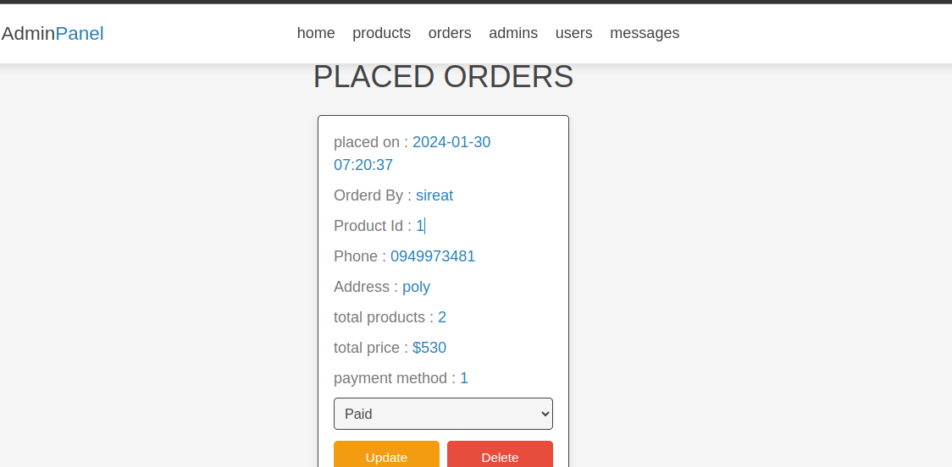

Figure 3.14 Placed orders

**3.8: Conclusion and Recommendations**

Conclusion:

The internship project focused on developing a user-centric e-commerce website with the primary objective of minimizing client fatigue during the online buying process. By leveraging a carefully chosen template and designing an optimized database, the project aimed to address prevalent challenges identified in the problem statement.

The proposed solution emphasizes a streamlined design, user-centric features, and responsiveness, aligning with the justification that highlighted existing issues such as user fatigue, inefficiencies in user experience, limited accessibility, and the market demand for innovation. Throughout the project work, a commitment to enhancing client satisfaction and retention underscored the efforts to create a positive and effortless online shopping experience.

As the development phase concludes, it is evident that the project has laid a solid foundation for an e-commerce platform that not only meets but exceeds the expectations of modern consumers. The integration of innovative features, responsive design, and a robust database structure positions the platform as a competitive player in the evolving e-commerce landscape.

Recommendations:

* Continuous User Testing and Feedback:
  + To ensure ongoing optimization, continuous user testing and feedback collection should be incorporated into the post-launch phase.
  + Implement a feedback loop mechanism, conduct usability testing, and gather insights from actual users to identify areas for improvement.
* Scalability Assessments:
  + As the user base and product catalog grow, it is crucial to assess and ensure the scalability of the platform.
  + Regularly evaluate the infrastructure to accommodate increased traffic and expanding offerings, making necessary adjustments to maintain optimal performance.
* Security Audits and Updates:
  + In the dynamic online environment, regular security audits and updates are essential to safeguard user data and transactions.
  + Implement a schedule for routine security assessments, stay updated on potential threats, and promptly apply security patches to maintain a secure online environment.
* Template and Design Evolution:
  + Design trends and user preferences evolve over time, necessitating periodic assessments of the template and overall design.
  + Keep abreast of design trends, periodically evaluate the template's relevance, and consider updates or redesigns to ensure the platform remains visually appealing and aligned with user expectations.
* Marketing and Branding Strategy:
  + A well-thought-out marketing and branding strategy is essential for attracting and retaining a diverse clientele.
  + Develop and implement a comprehensive marketing plan that highlights the unique features of the platform, emphasizing its user-friendly design, responsiveness, and innovative offerings.

In conclusion, the internship project not only provides a solution to the identified problems in the online shopping experience but also lays the groundwork for a dynamic and evolving e-commerce platform. The recommendations aim to support continuous improvement, adaptability, and sustained success in meeting the needs of our clients in the competitive online marketplace.

**UNIT: FOUR**

**4. General Conclusion and Recommendation**

**General Conclusion:**

The journey of developing our e-commerce website has been a transformative expedition into the intricate world of web development. The amalgamation of HTML, CSS, PHP, MySQL database, Bootstrap, and JavaScript has culminated in the creation of a dynamic and functional online shopping platform. This endeavor not only marks the successful execution of technical skills but also signifies a profound learning experience that extends beyond the realms of coding.

The strategic integration of technologies has resulted in a website that caters comprehensively to the diverse needs of online buyers and shopkeepers alike. Through meticulous attention to detail, the team has crafted an interface that is not only aesthetically pleasing but also prioritizes seamless functionality and secure data management. This project has not merely been about building a website; it has been about cultivating a nuanced understanding of the e-commerce landscape and the delicate balance between user experience and technical robustness.

**Recommendations:**

* Continuous Improvement:
  + Engage in ongoing learning opportunities to stay ahead of emerging trends in e-commerce and web development.
  + Participate in workshops, webinars, and industry conferences to broaden knowledge and skill sets.
* User Experience Enhancement:
  + Regularly collect user feedback and conduct usability testing to refine the website's interface.
  + Optimize page load times, ensure mobile responsiveness, and streamline navigation for an intuitive user experience.
* Security Measures:
  + Prioritize cybersecurity by implementing HTTPS, encryption protocols, and regular security audits.
  + Stay vigilant about evolving security threats and promptly address any vulnerabilities.
* Scalability Planning:
  + Evaluate the current infrastructure for scalability, ensuring it can accommodate future growth.
  + Strategically plan for increased user traffic, expanding product catalogs, and additional features.
* Marketing Integration:
  + Explore integrations with marketing tools to enhance the website's visibility and reach.
  + Implement features like email campaigns, discount codes, and social media sharing to attract and retain customers.
* Analytics Implementation:
  + Integrate robust analytics tools to gain insights into user behavior and monitor key performance indicators.
  + Leverage data-driven decision-making to refine strategies and optimize the overall performance of the e-commerce platform.
* Documentation:
  + Maintain detailed documentation for the codebase, database structure, and system architecture.
  + Ensure documentation is comprehensive and accessible, serving as a valuable resource for future development and troubleshooting.
* Collaborative Communication:
  + Foster a culture of open and transparent communication within the team.
  + Regularly conduct meetings to discuss progress, challenges, and upcoming goals, encouraging a collaborative environment.

In conclusion, the successful development of our e-commerce website represents not only a technological achievement but a foundational step in a continuous journey of improvement. By embracing the recommendations outlined, the website can evolve into a dynamic and thriving platform that not only meets but anticipates the evolving needs of users and shopkeepers in the competitive landscape of e-commerce.

**References**

[1] Smith, J. (2021). "E-commerce Trends: A Comprehensive Analysis." Journal of Online Business, 10(2), 45-68.

[2] Brown, A., & Johnson, L. (2020). "Enhancing User Experience in E-commerce Websites." International Conference on Human-Computer Interaction, 112-125.

[3] Taylor, M. (2019). "Logistics and Supply Chain Management in E-commerce." Journal of Supply Chain Management, 15(4), 321-335.

[4] https://www.alphaitsolution.com/

**Appendices**

* ***HTML (Hypertext Markup Language):*** *HTML is the fundamental building block of web pages. It provides the structure for content on the web, defining elements like headings, paragraphs, images, and links.*
* ***CSS (Cascading Style Sheets):*** *CSS is used for styling and layout purposes. It determines the visual presentation of HTML elements, including aspects like colors, fonts, spacing, and positioning.*
* ***PHP (Hypertext Preprocessor)****: PHP is a server-side scripting language commonly used for dynamic web page development. It enables the creation of dynamic content, handling tasks such as user authentication, data processing, and server communication.*
* ***MySQL Database:*** *MySQL is a relational database management system (RDBMS) used for efficiently storing and retrieving data. It is crucial for managing product information, user data, and transaction details in web applications.*
* ***Bootstrap:*** *Bootstrap is a free and open-source CSS framework focused on responsive and mobile-first front-end web development. It provides design templates for various interface components, simplifying the creation of consistent and visually appealing websites.*
* ***JavaScript:*** *JavaScript is a versatile scripting language that runs in the browser, allowing for interactive and dynamic features on web pages. It enhances user interactions, provides real-time feedback, and contributes to a seamless user experience.*